**PROJECT TITLE-SMART WATER FOUNTAIN- INTERNET OFTHINGS**

TEAM MEMBERS:

THIRUKUMARAN M

VIGNESH B

RAMPRASATH G

NITHISHKUMAR S

VASANTH S

MENTOR:

Ms. R Keerthana

**PHASE 4: DEVELOPMENT PART 2**

**PROBLEM DEFINITION:**

In this phase of the project, we will define the problem statement and outline a design thinking approach for the implementation of the Smart Public Fountain project. The project aims to provide real-time data on fountain availability and cleanliness to the public through a web-based platform or mobile app. This document will help us understand the project's objectives and how to proceed with its implementation.

**PROBLEM STATEMENT:**

Public fountains in busy areas often suffer from issues such as overcrowding, poor cleanliness, and lack of real-time information about their availability. This project aims to address these problems by implementing IoT technology to monitor fountain occupancy and cleanliness. The primary challenges to be addressed include:

1. Fountain Availability: Ensuring that fountain users have access to real-time information about fountain availability, minimizing wait times, and improving user experience.

2. Cleanliness Monitoring:Monitoring the cleanliness of fountains and ensuring timely maintenance to maintain hygiene standards.

3. Efficient Resource Management: Optimizing the allocation of cleaning staff and resources based on actual fountain usage and cleanliness needs.

DEVELOPMENT PART:

Design mobile apps for iOS and Android platforms that provide users with access to realtime fountain information

**Screenshots of the mobile App implementation part:**

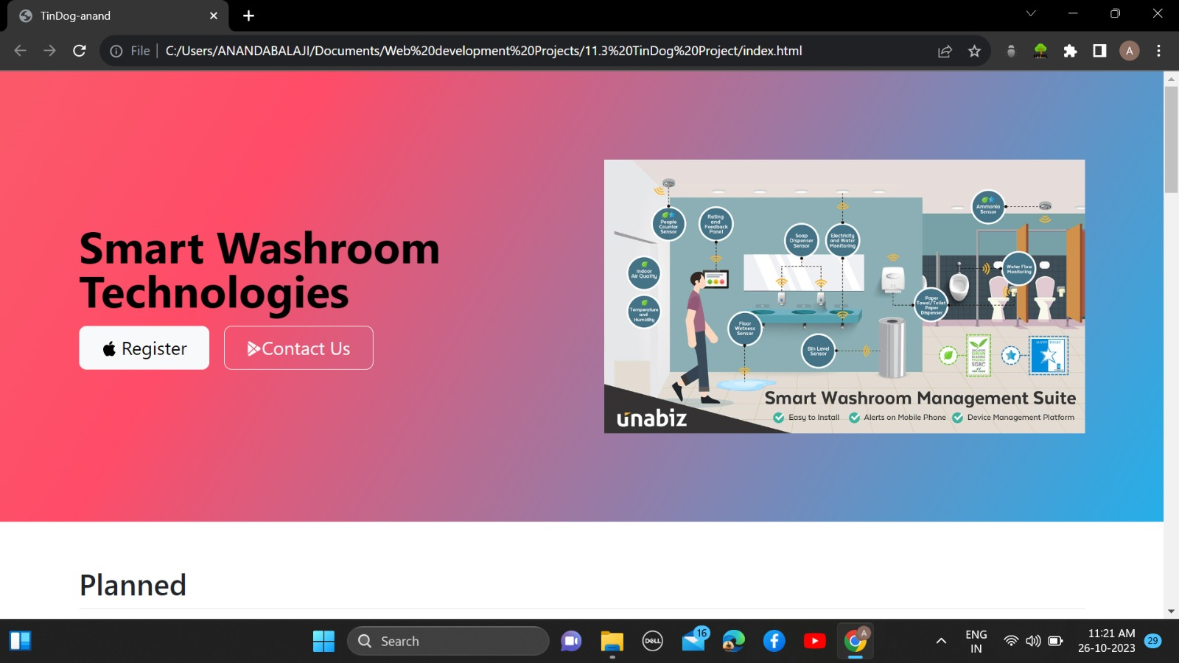

**Features:**

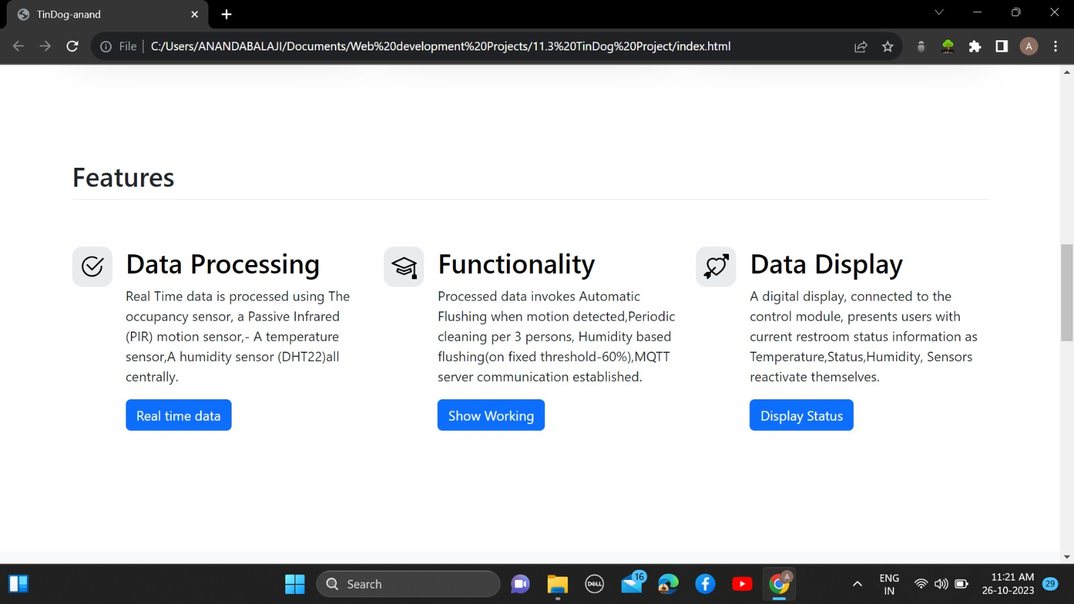

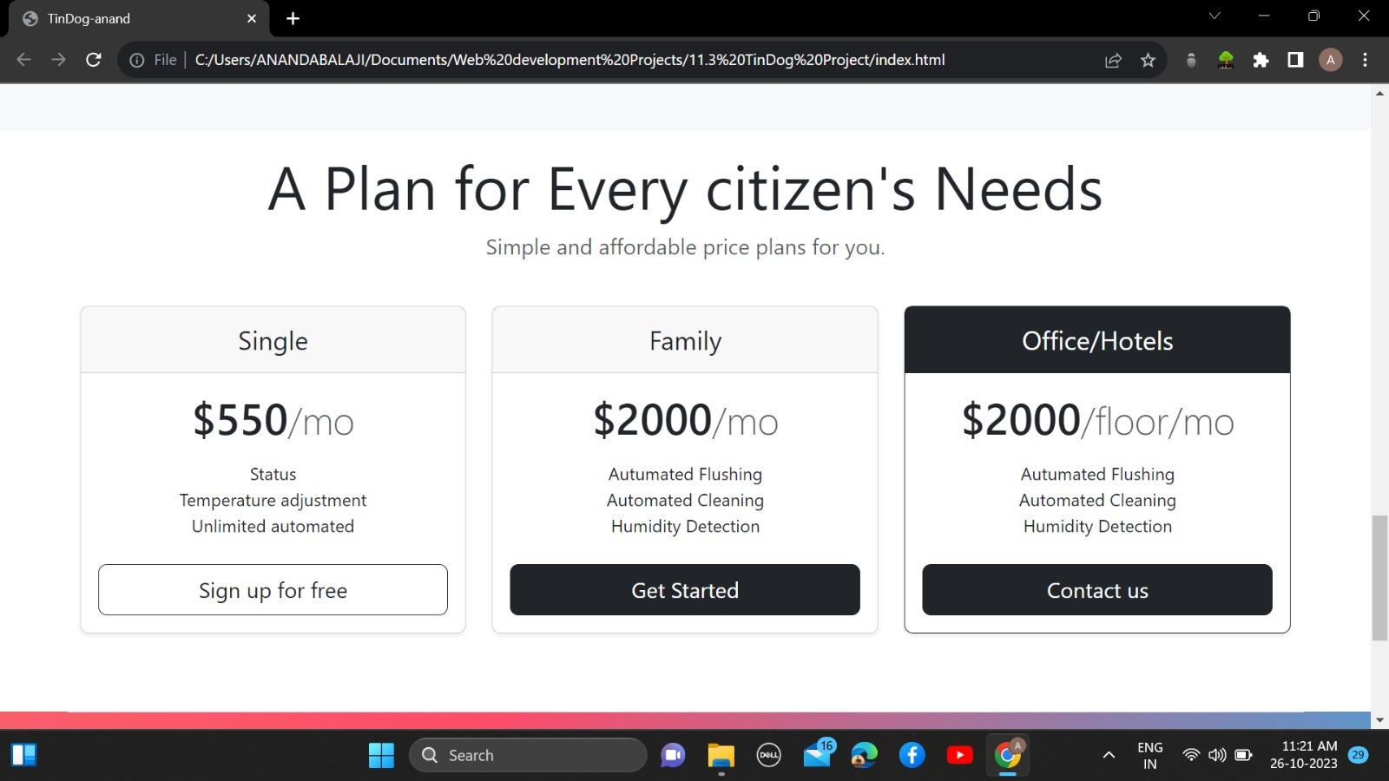

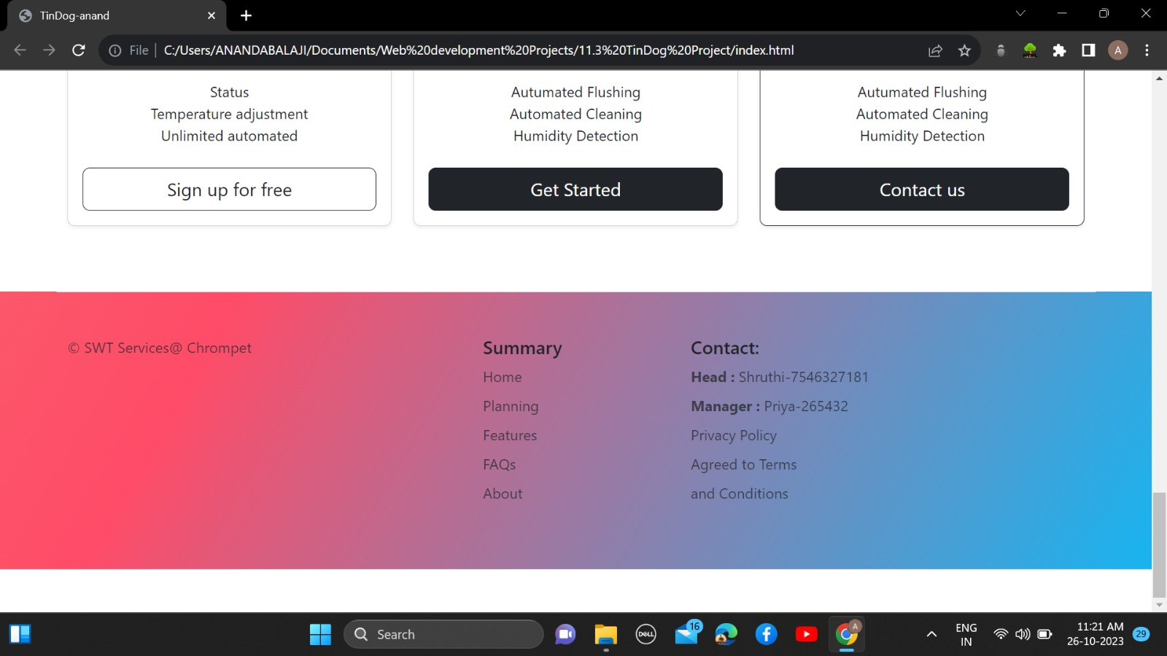

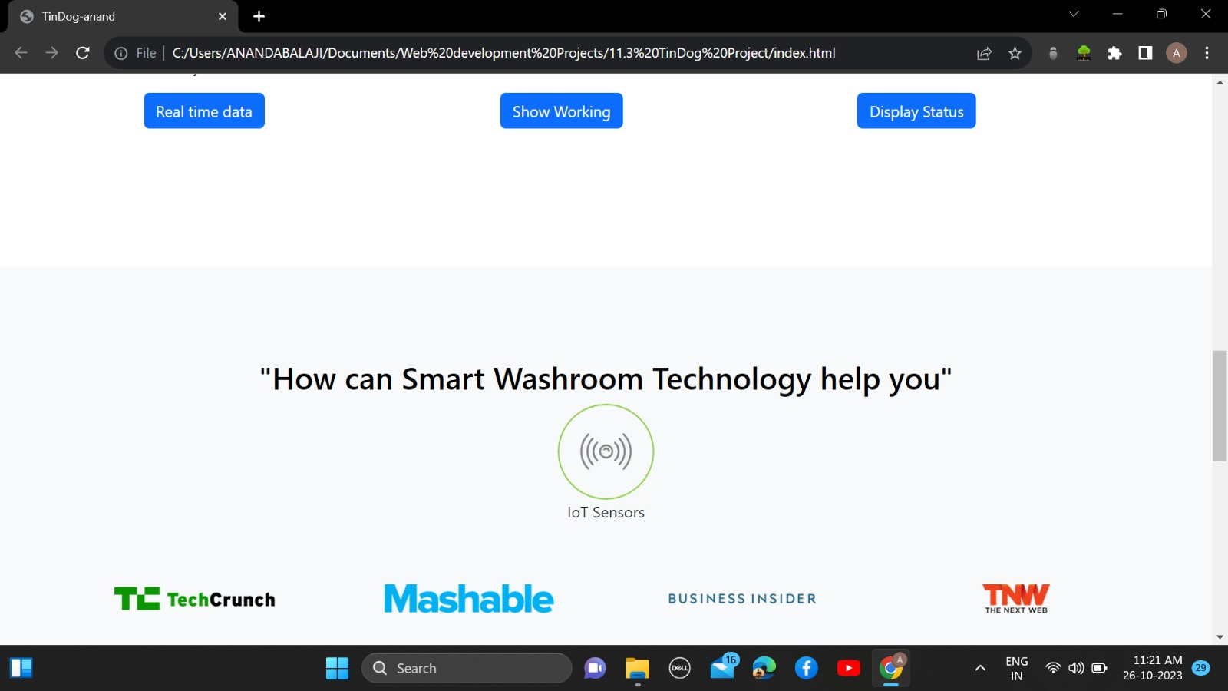

**Advancements:**

